1. Select any text and right click :-

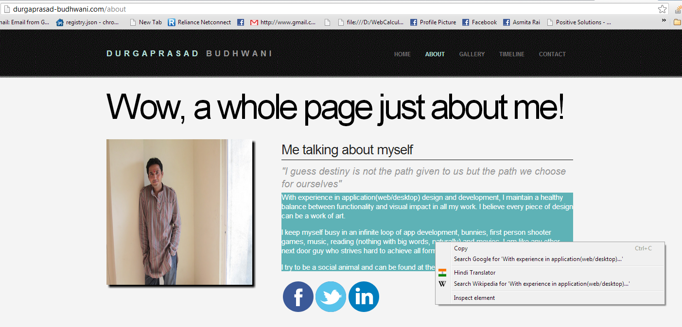

1. Click on Hindi Translator :-

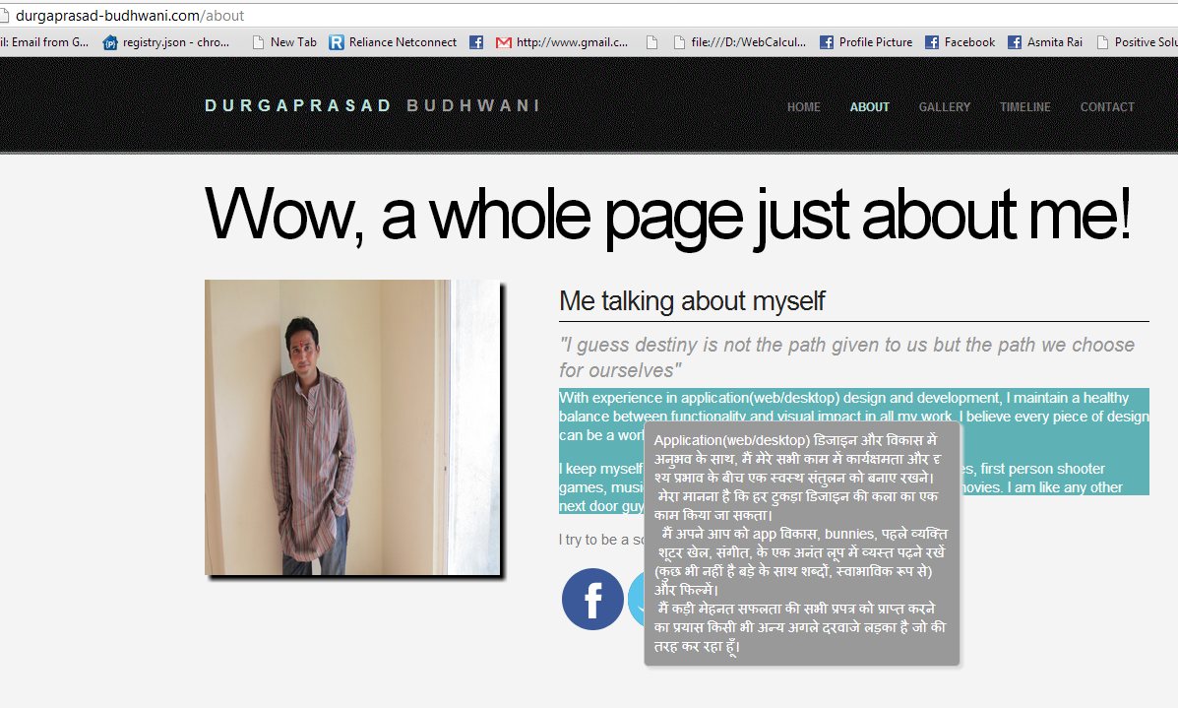

1. You will see selected text into Hindi tooltip format.